Answers | Coding Efficiency | Viva | Timely Completion | Total | Dated Sign of Subject Teacher
5 | 5 | 5 | 5 | 20
Date of Performance:....................................Date of Completion:..............................................

Assignment No: 2

- Title of Assignment:

Implement A star Algorithm for 8 puzzle game search problems.

Prerequisite:
Basic knowledge of Graph, Tree , informed search, uninformed search, best first search etc.

Objective:
In this experiment, we will be able to do the following:
  - To understand Informed Search Strategies.
  - To make use of Graph and Tree Data Structure for implementation of Informed Search strategies.
  - Study how A star Algorithm is useful for implementation of 8 puzzle game search problems.

- Outcome: Successfully able to implement 8 puzzle game search problem using A star Algorithm

Software and Hardware Requirement:
Open Source C++ Programming tool like G++/GCC, python,java and Ubuntu.
- Relevant Theory / Literature Survey:

Informed search
  - Informed search algorithm contains an array of knowledge such as how far we are from the goal, path cost, how to reach the goal node, etc.
  - This knowledge helps agents to explore less of the search space and find the goal node.
  - The informed search algorithm is more useful for large search spaces.
  - Informed search algorithms use the idea of heuristic, so it is also called Heuristic search

Heuristics function:
  - Heuristic is a function which is used in Informed Search, and it finds the most promising path.
  - It takes the current state of the agent as its input and produces the estimation of how close the agent is from the goal.
  - The heuristic method, however, might not always give the best solution, but it guaranteed to find a good solution in reasonable time.
  - Heuristic function estimates how close a state is to the goal. It is represented by h(n), and it calculates the cost of an optimal path between the pair of states.
  - The value of the heuristic function is always positive.

A* Search Algorithm:
  - A* search is the most commonly known form of best-first search.
  - It uses the heuristic function h(n), and costs to reach the node n from the start state g(n).
  - It has combined features of UCS and greedy best-first search, by which it solves the problem efficiently.
  - A* search algorithm finds the shortest path through the search space using the heuristic function.
  - This search algorithm expands less search tree and provides optimal results faster.
  - A* algorithm is similar to UCS except that it uses g(n)+h(n) instead of g(n).

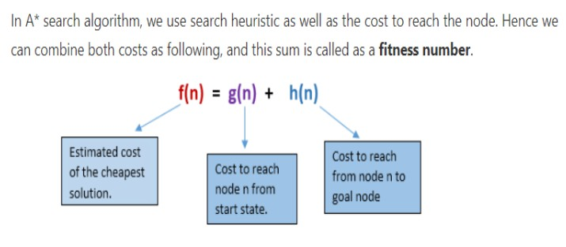

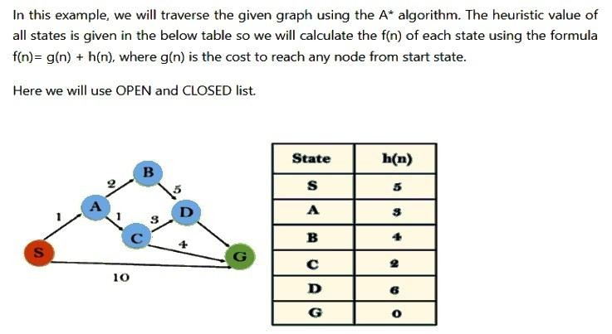
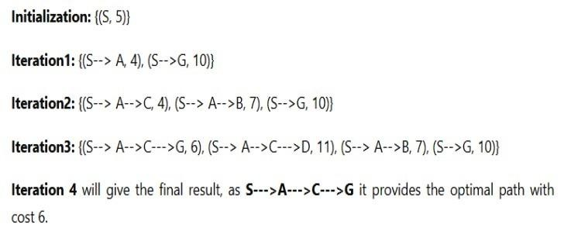

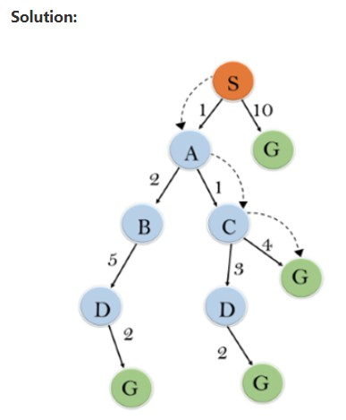

A* search Algorithm Advantages:
  - A* search algorithm is the best algorithm than other search algorithms.
  - A* search algorithm is optimal and complete.
  - This algorithm can solve very complex problems.

A* search Algorithm Disadvantages:
  - A* search algorithm has some complexity issues.
  - The main drawback of A* is memory requirement as it keeps all generated nodes in the memory, so it is not practical for various large-scale problems.

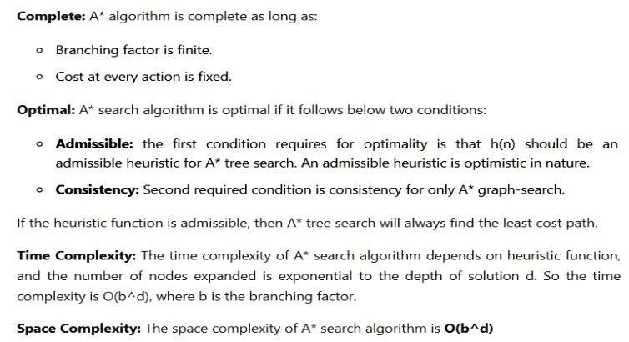

8 Puzzle Algorithm:-
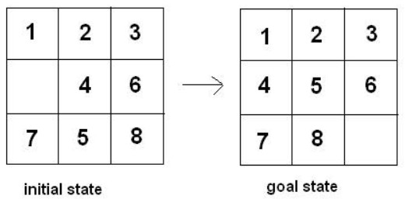
The 8-puzzle problem is a puzzle invented and popularized by Noyes Palmer Chapman in the 1870s. It is played on a 3-by-3 grid with 8 square blocks labeled 1 through 8 and a blank square. Your goal is to rearrange the blocks so that they are in order. You are permitted to slide blocks horizontally or vertically into the blank square.

There are a number of ways by which we can solve 8 puzzle problems.
  - Solution without Heuristic Function
  - Solution A* Algorithm


Solution without Heuristic Function
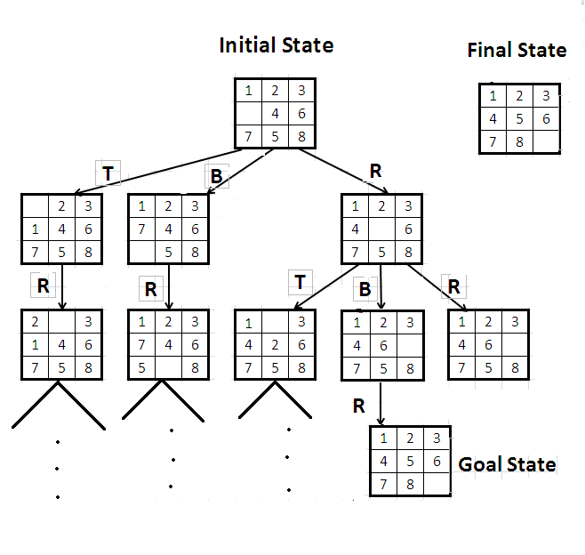

Disadvantages
need to explore each node and in case of failure need to generate its child which is a very time consuming as well as space consuming process.


Solution A* Algorithm

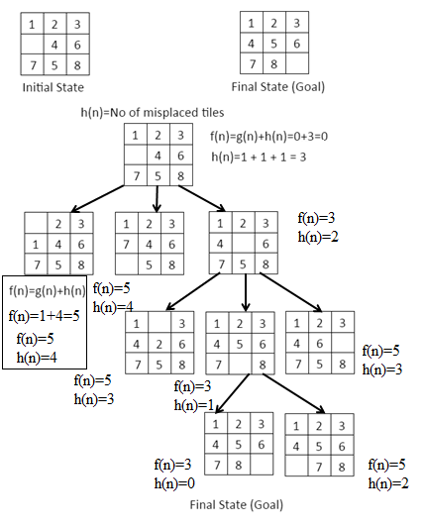

Questions:
Q 1: Differentiate between Best first search and A star algorithm.
Q 2: Solve this problem using A star algorithm
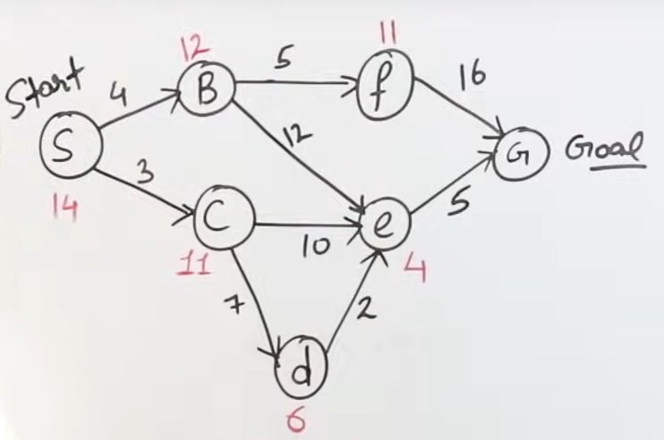
Q 3: What is the drawback to solve 8 Puzzle problem with a non heuristic method ?

Conclusion:
In This way we have studied informed search strategy, how to calculate heuristic function and implementation of 8 puzzle game search problems using A star Algorithm.

